Dipannita Biswas

Lecturer

Dept. CSE  
KUET

Md. Sakhawat Hossain

Lecturer

Dept. CSE  
KUET

Name: Sheikh Md. Galib Mahim

Roll: 2107020

Group: A1(10)

Submission Date: 2/10/23

**CSE 1204 | Digital Logic Design Laboratory**

**Digital Clock in Logisim**

**INSTRUCTED BY**

**PROJECT REPORT**

**OBJECTIVES**

* To Learn about 7 Segment display, flip-flop, and combinational Circuits.
* To Implement combinational and sequential circuits in Logisim.
* To make a digital clock using 7 Segment display, BCD to 7 Segment converter, 4 bit Up counter and 4 bit Comparator.

**INTRODUCTION**

Digital Logic is required in every aspect of modern life. From computers to simple clocks. In this project, a digital clock is designed and implemented in Logisim. Logisim is a simulation software that helps to design and simulate complex circuits. The special objective of this project is to make this clock skip a certain digit in seconds and minutes section. In our case , we need to skip “19” in our clock. Which has been obtained successfully, more about that in Design Section. This is a Team project of two people.

**Apparatus**

* 7 Segment Display - 6x
* BCD to 7 Segment Converter - 6x
* 4 bit Synchronous Up Counter - 6x
* 4 bit Comparator - 12x
* Clock pulse, Basic Gates, and Input outputs.

**Designing The Clock**

The clock was designed using two simple steps

1. First a simple basic clock was made.

2. The skipping mechanism was made.

**Making of Basic Clock**

**1. BCD to 7 Segment Converter:**

In this IC, a circuit is designed to take a BCD code as input and generate 8 outputs for a 7 segment display. The equations were found by making a truth table and Karnaugh maps for the segments. The equations were found by making a truth table and Karnaugh maps for the segments.

**Truth Table:**

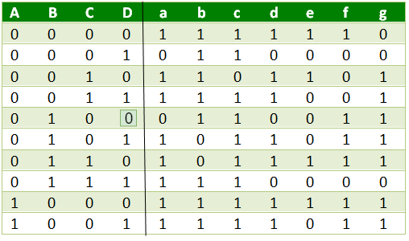

**Karnaugh Maps:**

For a: For b:

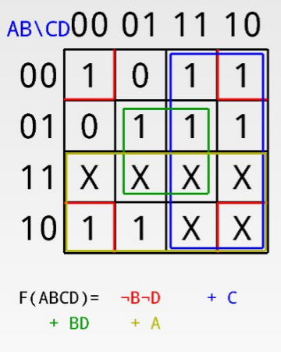 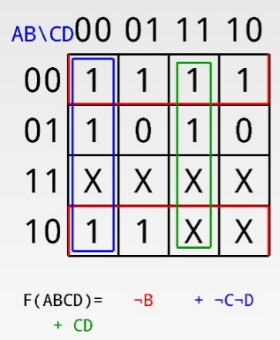

For c: For d:

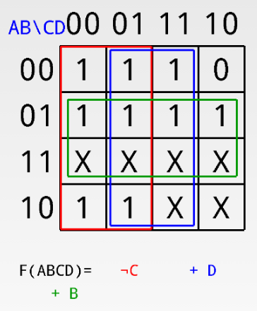 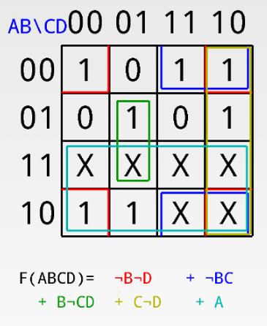

For e: For f:

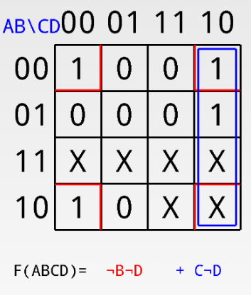 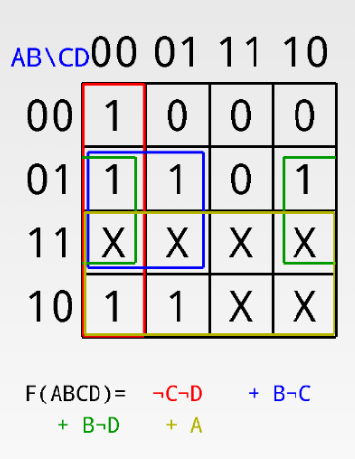

For g:

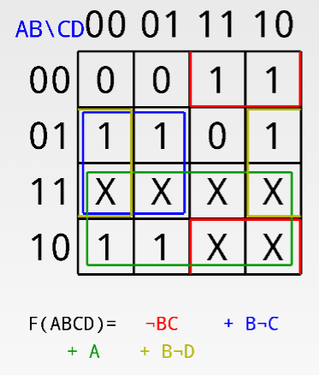

**Circuit Diagram:**

**2. 4 bit Up Counter :**

This is made using T flip-flops. This is a Synchronous up counter. Which Can count up to 15 or binary Equivalent “1111”. It is used as a counter in every 7 Segment Display and to achieve mod 6 or mod 10, additional combinational circuit is used in the main section of the clock design.

In this IC, a circuit is designed to take a BCD code as input and generate 8 outputs for a 7 segment display. The equations were found by making a truth table and Karnaugh maps for the segments.

Here we designed a 4 Bit Up counter using 4 T flip flops which was used to implement the circuits for hour, minutes and seconds.

**State Diagram: Excitation Table:**

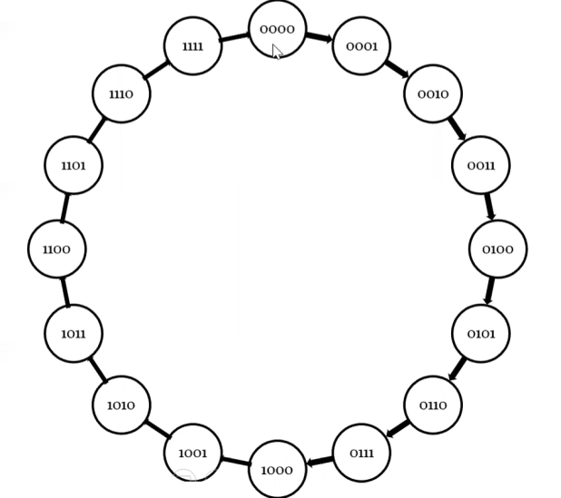 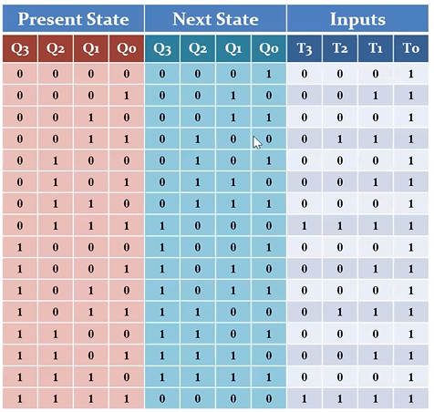

**Karnaugh Maps:**

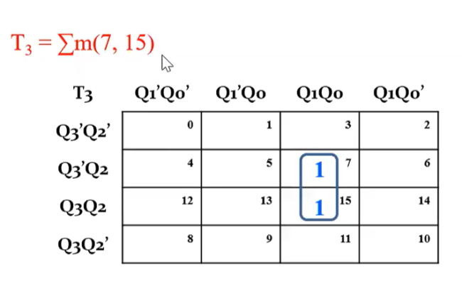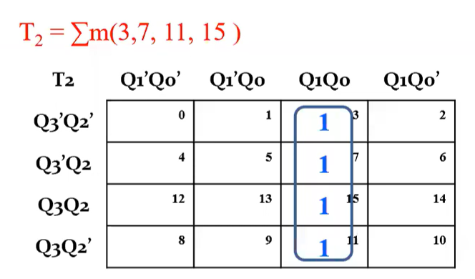

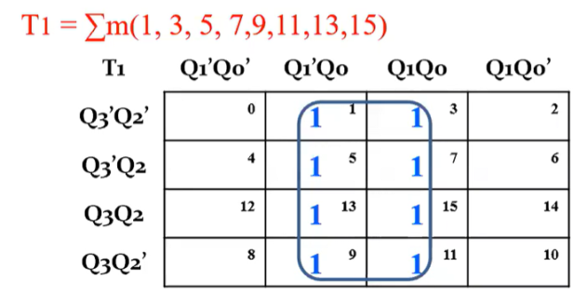 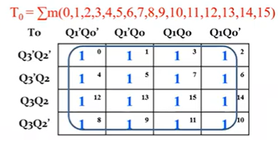

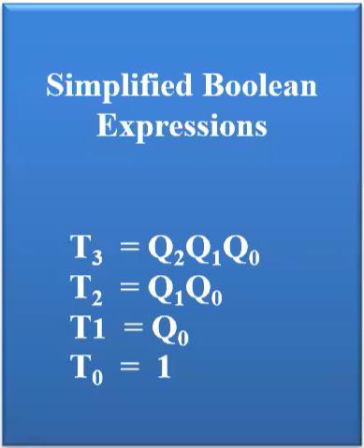

**Circuit Diagram:**

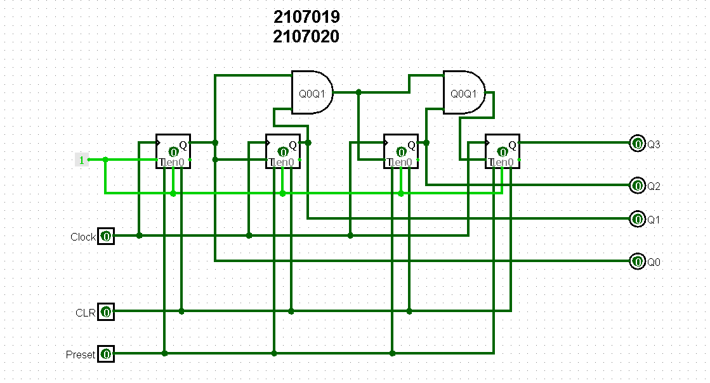

**3. 4 bit Comparator:**

This is made using 2, 2 bit comparator, and the 2 bit comparator is made using two 1 bit comparator. This is used to skip digit “19”.

1 bit comparator:

Truth table:

|  |  |  |  |  |
| --- | --- | --- | --- | --- |
| A | B | A < B | A = B | A > B |
| 0 | 0 | 0 | 1 | 0 |
| 0 | 1 | 1 | 0 | 0 |
| 1 | 0 | 0 | 0 | 1 |
| 1 | 1 | 0 | 1 | 0 |

Expressions:

A>B: AB'

A<B: A'B

A=B: A'B' + AB

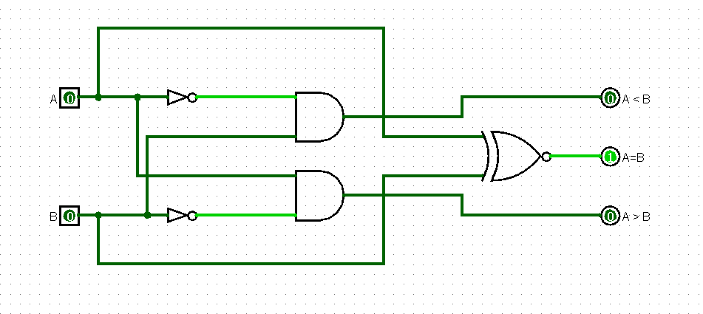Circuit Diagram:

**2 bit Comparator:**

using two 1 bit comparator , a 2 bit comparator is made, and it is made using logical algorithm.

If, A and B are two 2 bit numbers, represented by A1A0, B1B0

A > B : when A1 > B1 || A1=B1 & A0 > B0

A < B : when A1 < B1 || A1=B1 & A0 < B0

A = B : when A1 = B1 & A0 = B0

**Circuit Diagram:**

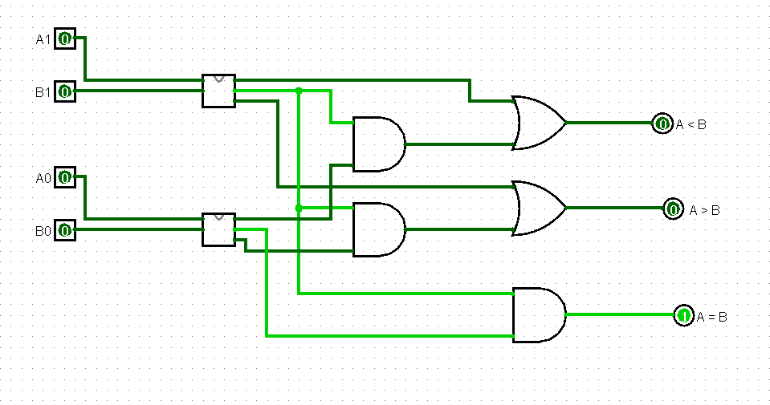

Here the 2 bit comparator is made following the above algorithm.

**4 bit comparator**

In a 4-bit comparator, the condition of A>B can be possible in the following four cases.

If A3 = 1 and B3 = 0

If A3 = B3 and A2 = 1 and B2 = 0

If A3 = B3, A2 = B2 and A1 = 1 and B1 = 0

If A3 = B3, A2 = B2, A1 = B1 and A0 = 1 and B0 = 0

Similarly, the condition for A<B can be possible in the following four cases.

If A3 = 0 and B3 = 1

If A3 = B3 and A2 = 0 and B2 = 1

If A3 = B3, A2 = B2 and A1 = 0 and B1 = 1

If A3 = B3, A2 = B2, A1 = B1 and A0 = 0 and B0 = 1

The condition of A=B is possible only when all the individual bits of one number exactly coincide with the corresponding bits of another number.

Using this algorithm the circuit was made

**Circuit Diagram:**

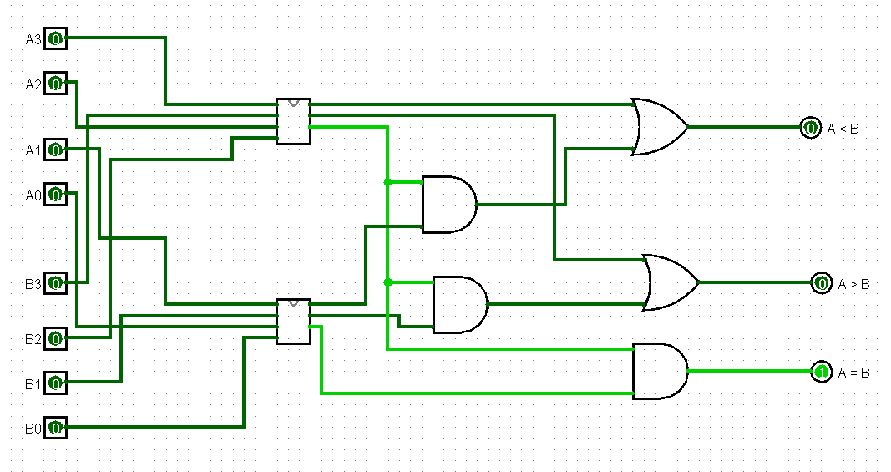

**Testing of basic clock:**

First, the circuit was checked, one 7 Segment display with mod 10.

When it was seen that, the clocking was perfect, that it counted from 0-9. Then, the circuit for showing Seconds was started.

**The logic behind modding:**

**Mod 10**

The counter counts from 0-15, so, when we needed mod 10. An AND gate was used to reset the counter. 10 -> “1010” so, Q3Q2Q1Q0, Q3 and Q1 was connected to the AND gate as input. When, the AND gate outputs 1, it gives 1 signal to clear of the counter, thus resetting the counter.

**Mod 6**

Similarly, mod 6 was made by Connecting an AND gate with “0110” so

Q2 & Q1. This mode 6 was used in both seconds and minutes circuit for the showing the second digit.

**Clock pulse:**

The clock pulse was only connected to the Seconds counters , First digit. The rest was made dependable according to this. When the First digit of the second counter got ‘clear’ input = 1, then the Second digit of the Seconds counter got a clock pulse.

Similarly, Minutes’ clock pulse came from on the Seconds counters , Second digit. And its own Second digit got the clock pulse from its First digit.

Then the clock pulse went to Hours’ first digit and so on.

**The magic of Skipping digit ‘19’:**

To achieve this we connected the Q3Q2Q1Q0 of both second and first digit to two consecutive 4 bit comparators. Q3Q2Q1Q0 was connected to the comparator via tunneling.

In showing the Second digit, whenever, Q3Q2Q1Q0 -> “0001” one of the two comparator gave signal 1 from A = B, as A was taken as Q3Q2Q1Q0 and B was fixed to “0001”.

And for the First Digit, A = Q3Q2Q1Q0 of first digit. And B = “1001” means digit 9. Whenever, A = B, it also gave a singnal 1, These two signal was then connected to an AND gate.

Then this output was connected via ORING with ‘clear’ signal giving AND gates output.

so the final output means,

If second digit -> “1” and first digit ->”9” skip. (gives 1 to clear of the counter of the first digit, and gives a clock plus to the second digit).

Similar thing was achieved for the minute.

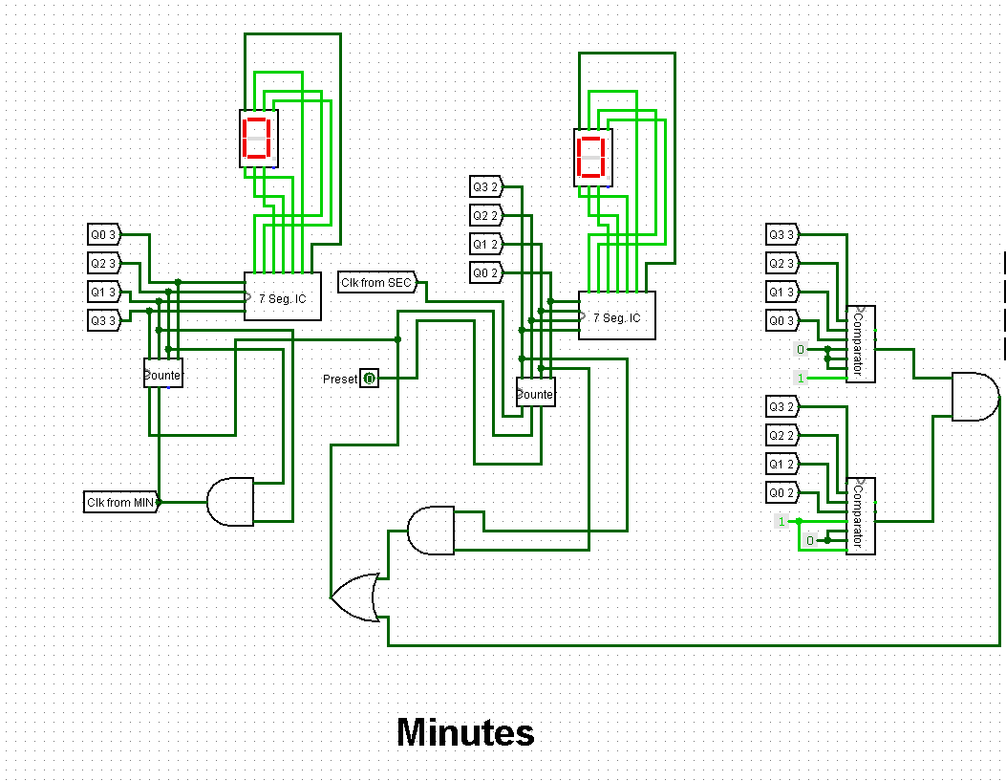

**Special Thing about Hours Circuit:**

Hours circuit is made dynamic, The Skipping Mechanism of Hour can be set as required. It can be turned on or off, depending on Users Choice.

Normally, in skip off situation, The hour will count upto ‘99’ then will go back to ‘00’.

In Skip on, we can choose it to skip at 12 or 24, thus making it a 12 hour clock or 24 hour clock.

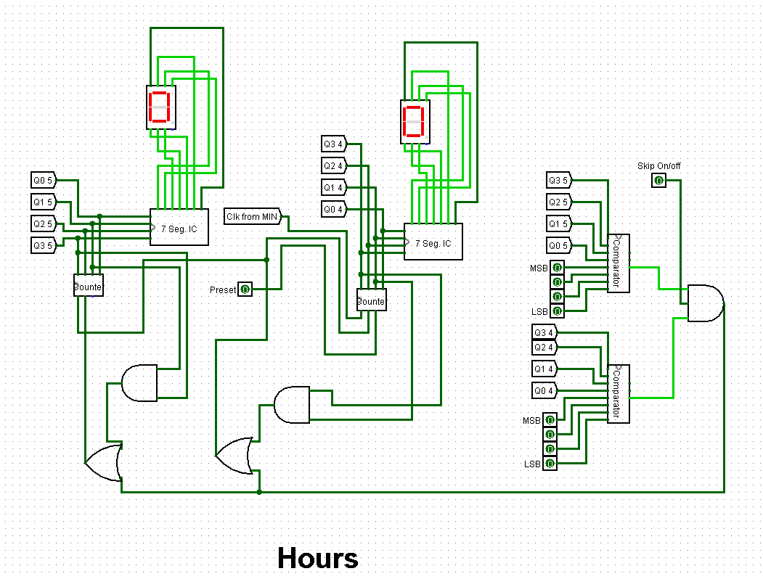

**DISCUSSION:**This project is a demonstration of all the concepts learned in the Digital Logic Design Laboratory Course. This was a team project of two students. We tried to work simultaneously on the project. To get the Idea, help from online resources was taken.

It was tried to make things as simple as possible. All the circuits and IC were self-made except for the T flip-flop, which came built-in inside Logisim. Tunneling was used to make the circuit look elegant.

**CONCLUSION:**

The fundamental objective of this project was to learn and implement ideas of combinational and sequential circuits and using this make a Digital Clock in Logisim. This was successful via implementing and designing the Clock from Scratch.

**REFERENCES:**

[**https://www.geeksforgeeks.org/magnitude-comparator-in-digital-logic/**](https://www.geeksforgeeks.org/magnitude-comparator-in-digital-logic/)

[**https://www.youtube.com/watch?v=bDTYoaxueQ4**](https://www.youtube.com/watch?v=bDTYoaxueQ4)

[**https://www.youtube.com/watch?v=fyyEMd7KvPI**](https://www.youtube.com/watch?v=fyyEMd7KvPI)

**BOOK:** Digital Logic and Computer Design

Author: M. Morris Mano